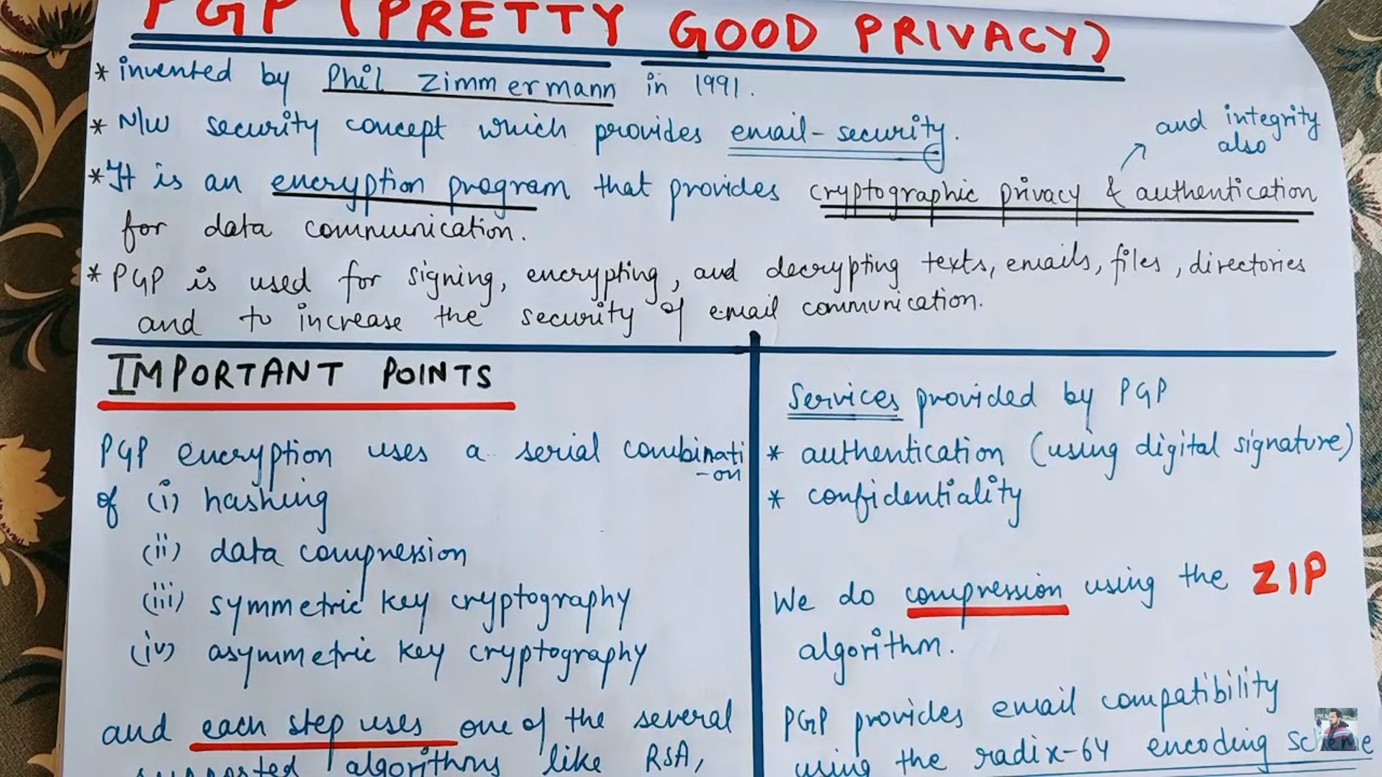

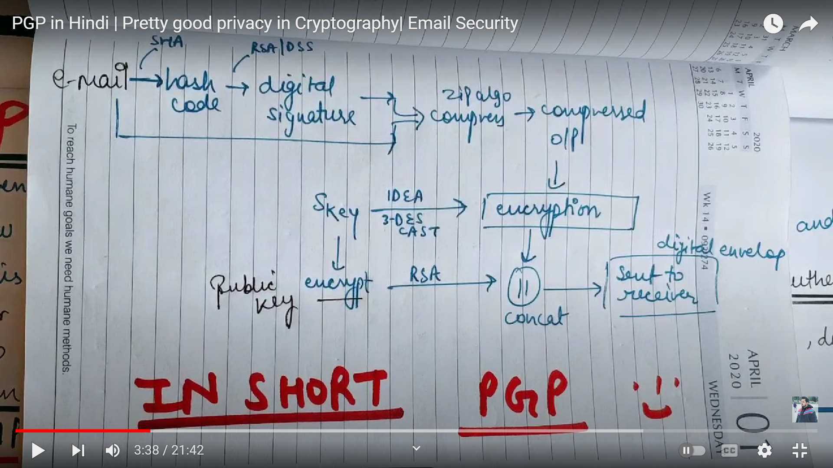

YO SHORT DESCRIPTION WALA DIAGRAM STEP 3 KO HO

@Heck: hash encryption compression

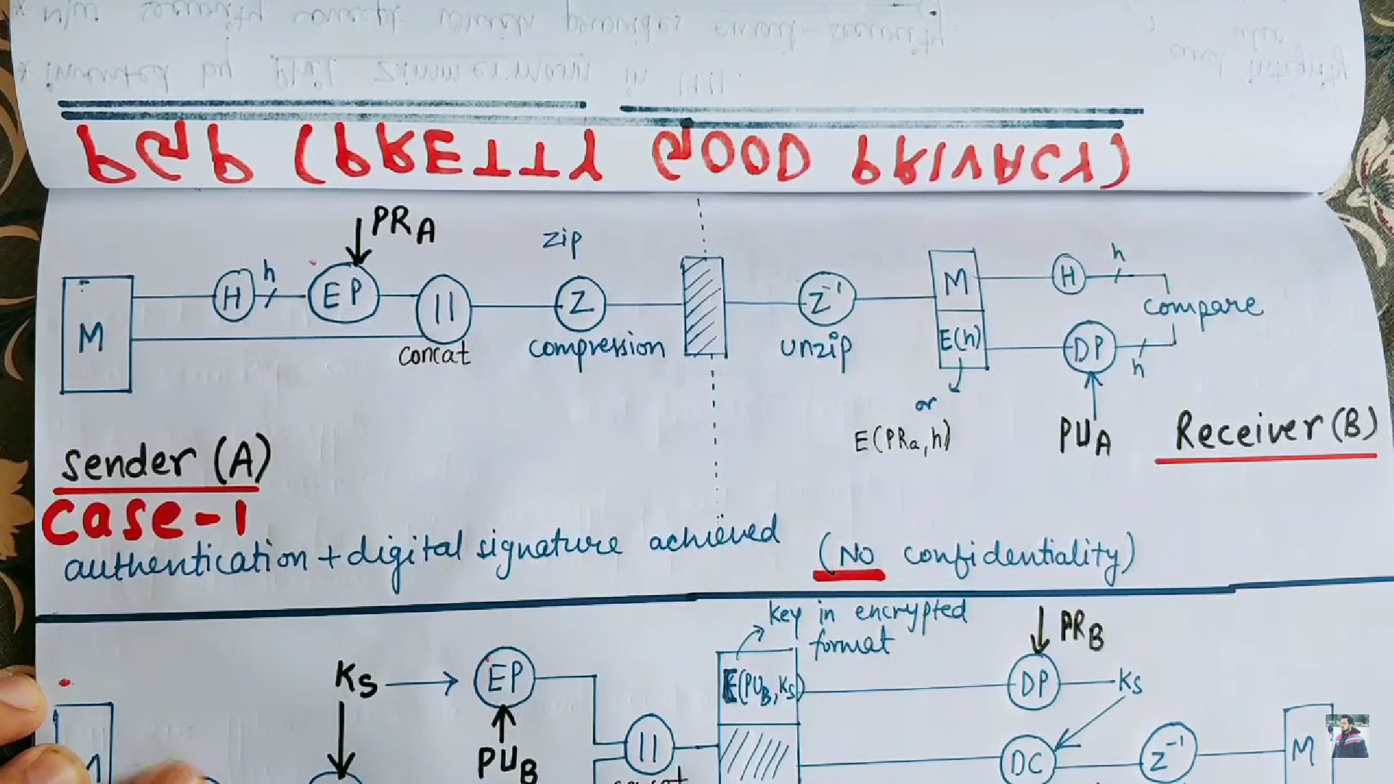

CASE 2 MA CHAI HASH PANI HUDENW 1 KAE ULTO HO SURU MA COMPRESSION ANI ENCRYPTION

Ks vneko secret key ho tesle compress message lai encryption grxa ani tyo secret key lai chai feri receiver ko public key le encryption vairaxa

